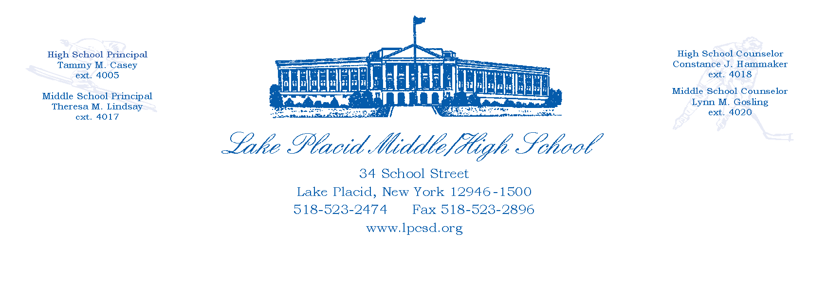

Date:_______________________________

Student Name:_____________________________________________________

As a professional photographer, I,________________________________(printed name), herby grant permission to reprint the photo(s) taken by me in the graduation special in the Adirondack Daily Enterprise and the Lake Placid News.

Lake Placid High School, herby grants permission to reprint photographs that appeared in the school yearbook or were submitted to us with reprint permission from the phographer or business.

_________________________________

(Photographer Signature)

Parent/Guardian,

If this picture was not taken by a professional photographer, please sign below granting us permission to use your child’s photo.

__________________________________

(Signature)